**SUBCON User Manual**

**Table of Contents**

***1*** ***Introduction 3***

**1.1** **Who can benefit from Sub-Contractor System 3**

**1.2** **Key Features of Sub-Contractor System 3**

***2*** ***Requirements 3***

**2.1** **Minimum Device Requirements 3**

***3*** ***Getting Started 4***

**3.1** **Download the Sub-Contractor Application 4**

**3.2 Subscription 4**

**3.2 Registration 4**

**3.2 Log In 5**

**3.2 Forgot Password 6**

***4 Home screen 7***

**4.1 Project Status// Optional 8**

**4.2 Issue Invoice 9**

**4.3 PO list// Optional 11**

**4.3.1 PO Details //Optional 12**

**4.4 Invoice Summary 13**

**4.4.1 Delete Invoice 14**

**4.4.2 Invoice Detail Summary 15**

**4.4.3 Upload Payment through Invoice Summary 16**

**4.5 Upload Payment 16**

**4.6 Invoice Status 17**

***5 Sidebar Menu 17***

**5.1 Profile 18**

**5.1.1 Change Password 19**

**5.2 User List 20**

**5.3 Payment History 20**

**5.3 Roles 21**

**5.3.1 Page Permission 22**

**5.4 Assign Roles 22**

**5.5 Signature 22**

**5.5 Logout 23**

# 1 Introduction

Maintaining a project management system can be a tedious affair. The SUB Contractor system is an application that greatly simplifies and assists the process of keeping track of a project and creating invoices. The benefits of the additional features make it a very worthwhile system to use.

This system combines the management team into one platform to supervise each ordered project and simultaneously create and issue invoices.

## 1.1 Key Features of Sub-Contractor System

* A user-friendly and well-designed online system
* Invoice generation
* Biometric System for stronger security
* Subscription period from the date of subscription
* Easy to add roles of the employee
* Easy to update payment method
* Frequent project status tracking
* Frequent invoice status tracking
* Easy to check the history

# 2 Requirements

## 2.1 Minimum Device Requirements

The minimum requirements for running the Application to operate the Sub Contractor System are listed below:

* Any Android versions
* A internet connection
* Must be a Smart Phone
* Front-facing camera if using the biometric face/iris scanning login feature.

# 3 Getting Started

## 3.1 Download the Sub-Contractor Application

The Sub-Contractor System is an application used to track projects and issue invoices for the work given.

Download and install this application after connecting to the device having an active internet connection

1. Navigate to the *Android Play Store and search Sub Contractor System*
2. Click on the relevant download icon.
3. Once the installation is complete, you are ready to connect your device for the first time.
4. Go to your home screen and start using the system.

## 3.2 Subscription

Subscription is done by the company that wants their employee to use the system. One person will be in charge of managing the user and their roles and additional support can be provided by SOR. Employees that wish to use the system do not need to subscribe to the system personally and just have to ask for the reference number from the person in charge of the system on the company side.

## 3.3 Registration

1. Firstly, the user has to give the reference ID/No of the company.
2. If the reference ID/No under the specific company is correct, the user will then be able to fill up the signup fields.
3. Users must provide their complete name, username, email address, phone number and password.
4. The signup button will be activated only when all the fields are entered correctly.
5. After successful registration, a feedback message will appear.

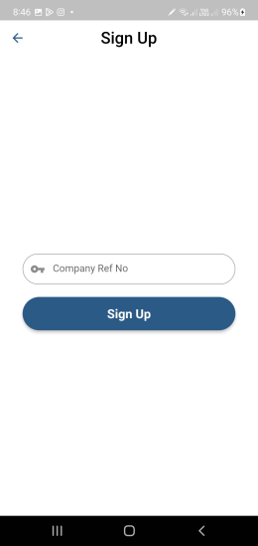 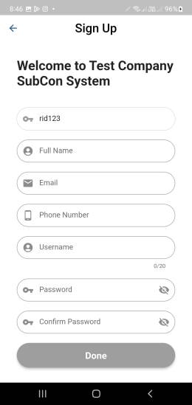

## 3.4 Log In

1. After that, the user will be redirected to the Login screen.
2. Users can log in two ways. Either by giving a registered username and password or through biometric scanning which includes a fingerprint scan, and face recognition, iris scan.
3. The biometric system depends on whether the phone offers biometric technology.
4. The user must provide the correct login credentials to activate the sign-in button.
5. The user has to wait for approval by the system manager to permit the user account to be let into the system.

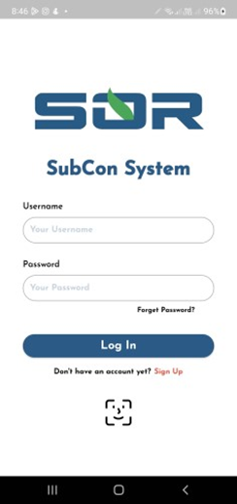

## 3.5 Forgot Password

1. For Password recovery, users can find it on the login screen beneath the password field.
2. The user must provide a valid email address.
3. Within that email, an OTP will be sent in which the recipient must enter their OTP value.
4. If the user exists, the verification will enable them to change their password.

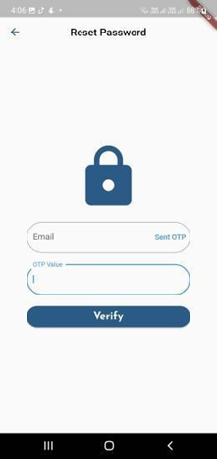

# 4 Home screen

The user is sent to the home screen after successfully logging in, where the choices Main Menu, Project Status, Issue Invoice, PO list, Invoice Summary, Upload Payment, and Invoice Status are listed along with the user's name.

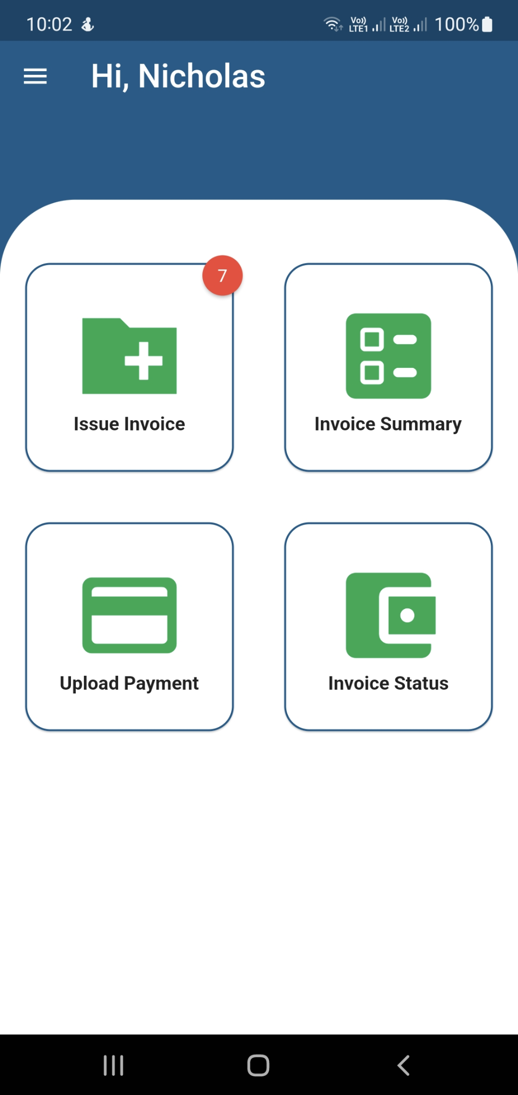

## 4.1 Project Status// Optional

1. Users may search here by any field except for PU ID and filter.
2. There are two drop-down filters naming status and claim status
3. Status consists of Ongoing Project status and Completed Project status. If the user chooses any one status the page will view only the projects under that category of status.
4. Claim Status consists of Nothing to claim, Approved, and No work done categories of claim status. If the user chooses any one of the claim statuses the page will view only the projects under that category of claim status.
5. PU Id is the unique Identification of each PU under each PO.

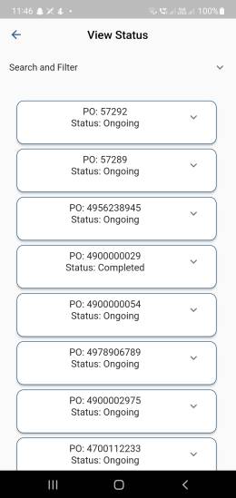 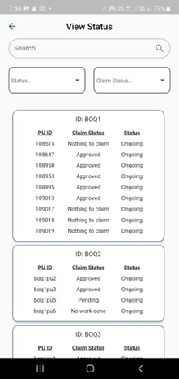

## 4.2 Issue Invoice

1. Users may search here by PO ID and filter
2. Users can view PU ID and Claimable Quantity
3. Claimable Qty means the quantities which are ready to be issued by the Subcon and approved by the Main-Con
4. To create an invoice, users can select one PO radio button at a time, as a result, the system automatically will tick all the PU listed under that particular project.
5. If the user wants to select a certain PU then the user can click from the specific checkbox.
6. When the user has selected the PUs an action pop-up will appear asking for the Invoice No and Date and two buttons named Cancel and Create.
7. The user has to enter Invoice No
8. The user can set the date according to the date, month, and year.
9. After setting the Invoice No and date the user may now press the Create button.
10. The Create button will check for any overlap in invoice contents and then generate the invoice.
11. The share button below will share the Invoice as a PDF to other available applications.
12. It will allow the user to download the PDF into the device.

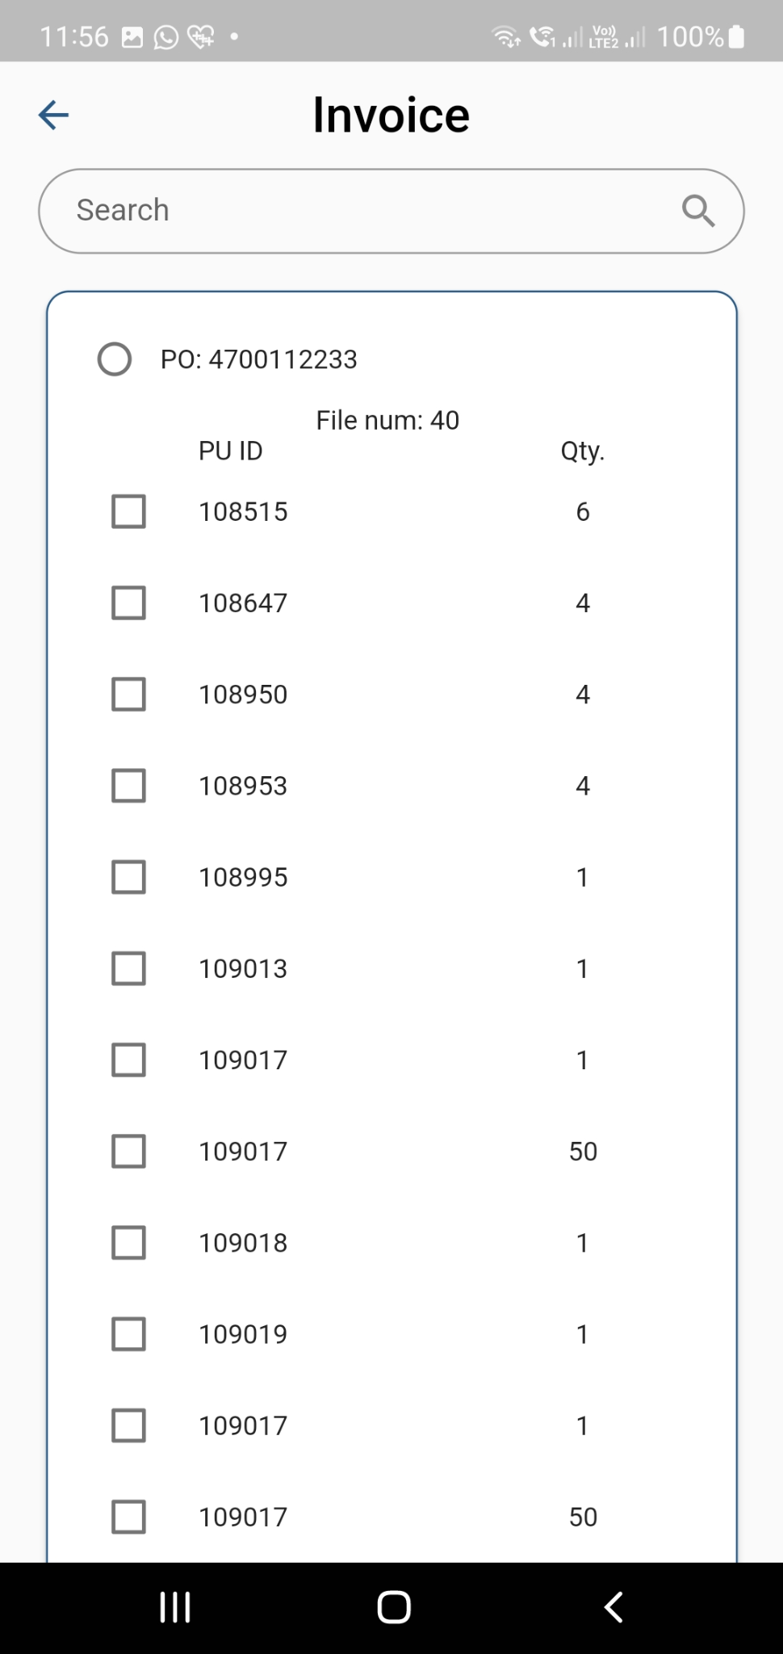 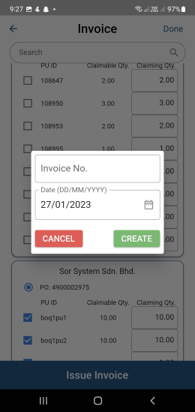

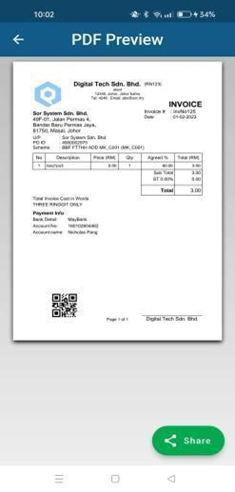

## 4.3 PO list// Optional

1. This page is informative because it contains all the PO records.
2. Users may search here by PO ID(last four digits also work) and Company name
3. There is one drop-down filter naming payment status.
4. Payment status has five categories All, Not paid, Partial Pay, Fully Paid, and OverPaid.
5. If the user chooses any one of the payment statuses the page will view only the projects under that category of payment status.
6. Users can view the scheme, PO No, Phy(%) Avg, Amount, Amount Paid, Payment Status, and Remark.

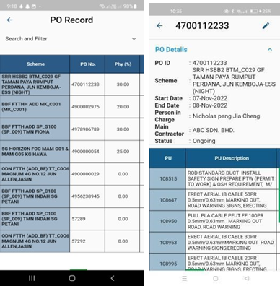

### 

### 4.3.1 PO Details //Optional

1. The Po details page can be found by pressing on any of the fields inside the PO list.

2. As a result, it will directly route to the Po details screen where the specific PU information will be found.

3. There is an edit button on top of the screen.

4. The Edit button is for changing the Quantity done.

5. The quantity done cannot be greater than the Inst. Qty. or else it would be invalid.



## 4.4 Invoice Summary

1. An invoice summary of the details of the generated invoice.
2. Users may search here by invoice No, file number, date, amount, created by, status, and paid amount.
3. There is a drop-down filter named status to filter the table by the payment status of the invoice.
4. The drop-down status has five categories: All, Not paid, Partial Pay, Fully Paid, and OverPaid.
5. If the user chooses any one of the statuses the page will view only the projects under that category of payment status.
6. If the user wants to “Print” the invoices they can also Print from the rightmost print option.
7. There are two sticky footers at the bottom of the screen that show the overall amount in “Total Bills” to be paid for the invoices listed and another one is the overall amount in“Total Paid”.
8. If the user wants to “Delete” any invoices, there is a delete button on top of the screen which will redirect the user to the “Delete Invoice “screen.
9. Deleting invoices is also permission based thus it will only show users with access permission to delete invoices.

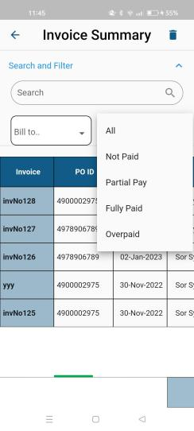

### 4.4.1 Delete Invoice

1. Along with a red "Delete Invoice" button, are all the details for the produced invoices.
2. To delete an invoice, users can click on the ‘Delete Invoice’ button or swipe to the left.
3. A confirmation message will appear on the deletion of the invoice.
4. The user may click on "Delete" if they are certain and cancel to undo.
5. After confirming, the invoice will be deleted from the system.

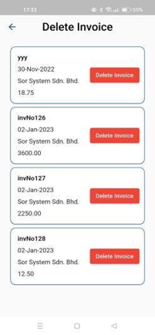

### 4.4.2 Invoice Detail Summary

1. If the user taps on any field of the Invoice summary they will be routed to the detailed page of the particular invoice.
2. A list of information will be displayed on the top of a table of the details of the invoice.
3. The table will show the PU ID, quantity, Rate, agreed percentage, and price.

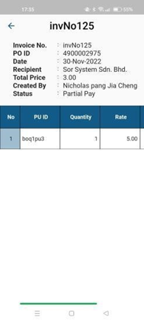

### 4.4.3 Upload Payment through Invoice Summary

1. If the user wants to pay directly from the Invoice summary then the user must long press on the specific invoice row.
2. A pop-up will appear at the bottom right named “Upload payment invNo …”.
3. Pressing the button will route the user to the Upload Payment Screen.
4. A fully paid invoice will not be allowed to upload payment.
5. Since the user has already selected invoice No, only the Payment Amount will be asked this time.

## 4.5 Upload Payment

1. This screen is used to upload payment
2. The user will write the Invoice No or search for the wanted Invoice No from the drop-down.
3. After selecting the invoice, the payment amount will be shown based on the invoice selected.
4. The user can change the date of the payment to a specific date and the payment amount.
5. Users will then click on the button to upload payment.

For any kind of payment which exceeds the amount to be paid or Overpay then the system will show a prompt confirmation message.

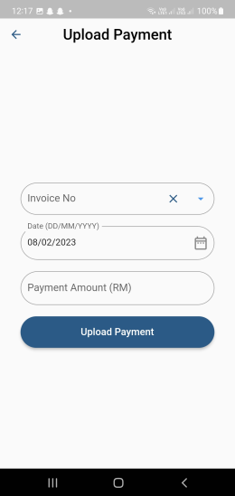

## 4.6 Invoice Status

1. This screen will display graphical information on all the invoices.
2. Users can search by Invoice No, amount, paid amount, and status
3. A drop-down filter shows the status of payment on the invoice.

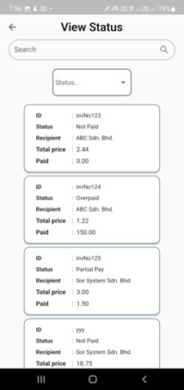

# 5 Sidebar Menu

There is a sidebar Icon at the top left part of the screen. Which helps the users to seek the supplementary contents of the main contents. Where there is User Profile, User List, Payment History, Roles, Assign roles, Signature and Log out.

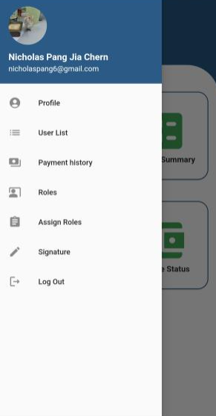

## 5.1 Profile

1. This screen is the user profile screen.
2. Users can pick their image after clicking the pen icon next to the image.
3. Images can be selected from their photo library.
4. Every field is editable inside the profile screen.
5. The edit button lets the user edit their name, username, email, and phone number.
6. To save the change press “Save”.
7. For changing the password user will be redirected to a new change password screen.

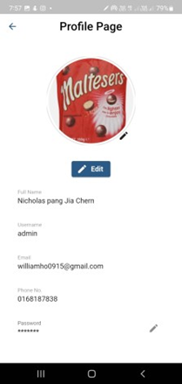

### 

### 5.1.1 Change Password

1. The user enters their current password.
2. Next, the user enters the new password.
3. The new password is also entered in the confirm password field.
4. Click the "Change password" button to change the password.
5. A feedback message will appear on the result of changing password

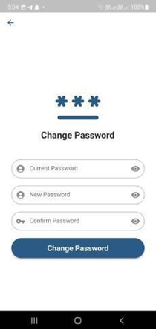

## 

## 5.2 User List

1. The user list page shows the list of users that sign up for the company.
2. There is a drop-down filter to filter the status of the user in the company.
3. The admin can approve and un-approve the user that signed up.
4. Unapproving the user will restrict the user from accessing the system.
5. There is a set user role button at the bottom of the screen.
6. The set user role button will redirect the user to the Assign role screen.

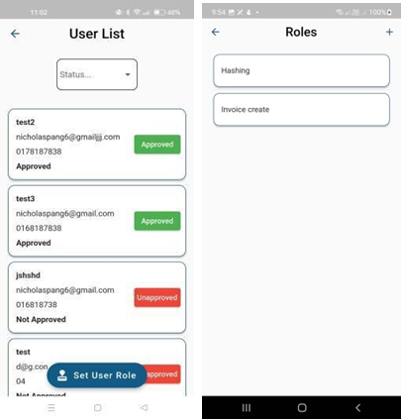

## 5.3 Payment History

1. This screen will display table information on all payment transaction history.
2. The two choices are Edit and Delete on click on table
3. the user can then choose to either delete or edit the payment statement.
4. the option will only be visible when there are existing payments

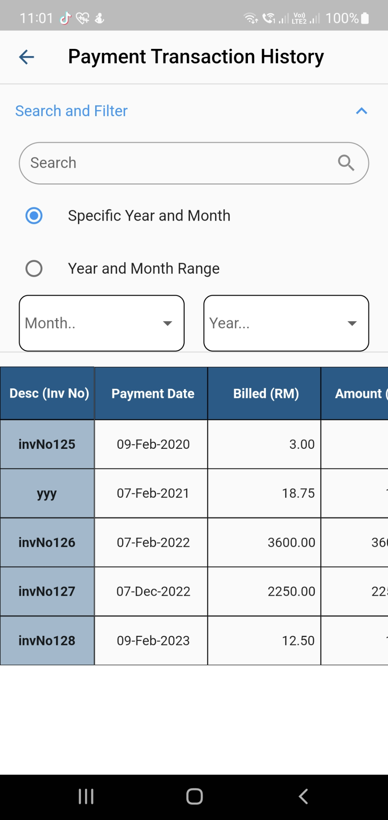 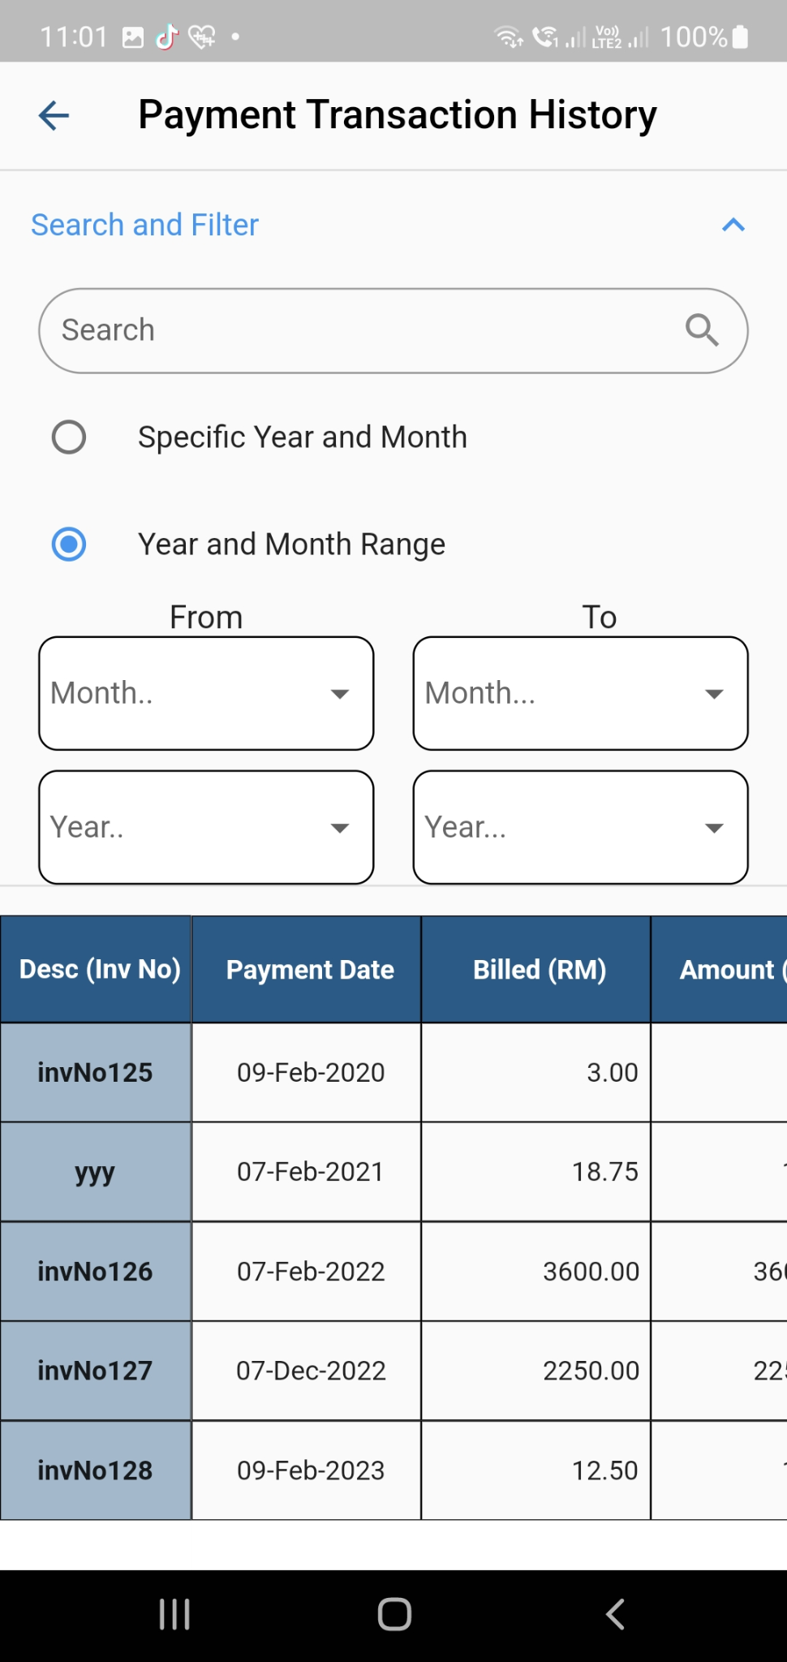

## 5.3 Roles

1. Roles are where the admin can manage roles.
2. While a role can have numerous users, a user can only have one role simultaneously.
3. To create a role and its access permission, click the "+" in the upper right corner of the page.
4. to view the permissions on a role, the admin can click on the card of the role.
5. To delete a role, the admin can swipe the role to the left to delete it. A confirmation message will appear to ask the admin for confirmation.
6. User with the role that the admin deleted will have no role set.



### 5.3.1 Page Permission

1. There is an arrow that will expand the “permission” where the admin can set the permission accordingly.
2. Only the white boxes can be set to permission.
3. After creating a role, the administrator can “save” the role by pressing the save button from the top right corner
4. A confirmation message will come out to ask for confirmation from the admin.

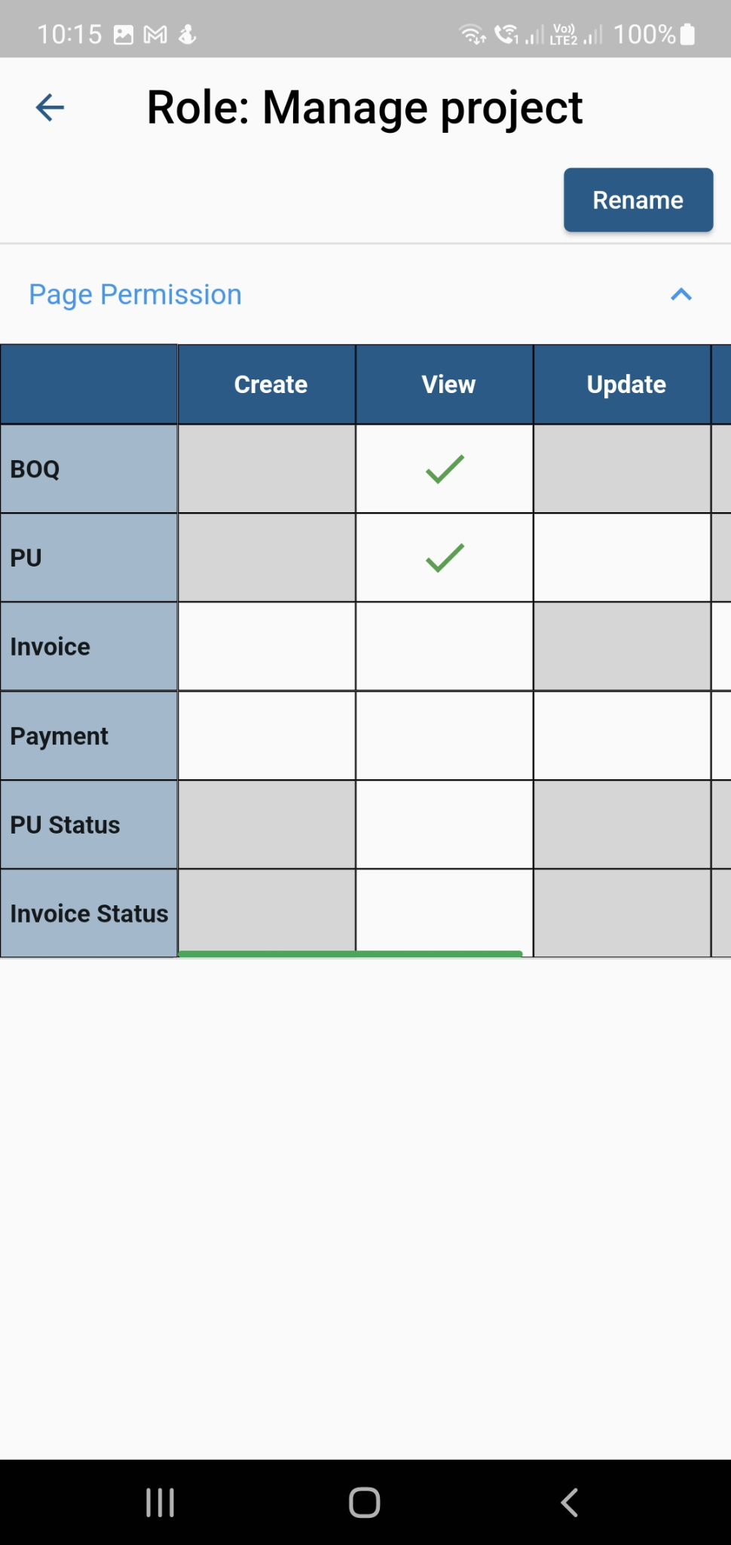

## 5.4 Assign Roles

1. The admin can assign roles to users.
2. When you click the green Assign button on a user's card, a pop-up window with a drop-down list will display.
3. If the administrator assigns a different role, the previous role state will change, and a prompt message. then if you are sure press Continue or else cancel.
4. The administrator cannot give the same job to a user if that role has already been assigned to him. if the administrator assigns the same role as before, nothing will change, and a prompt message requesting “ Please assign a different role to the user”.

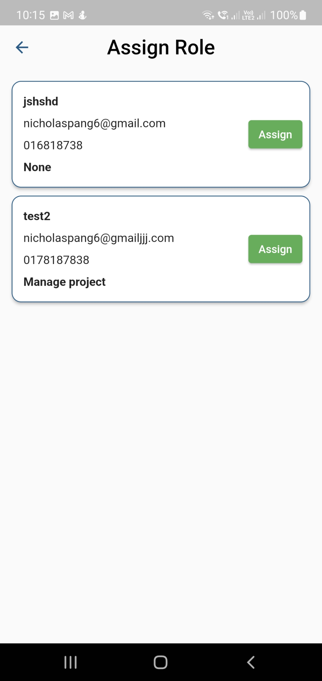

## 5.5 Signature

1. The user can create a digital signature and set their own signature preferences for invoices on the signature screen.
2. The options for the user's signature preference are "Leave it blank" and "Use Authorised Signature".
3. The setting of "Leave it Blank" will not have any digital signature in the signature area of the invoice.
4. The setting of “User Authorised Signature” will have the signature of the user as the signature for the invoice.
5. There will appear a signature pad when clicking on the expansion tile “Signature”. The user can make their signature.
6. Users can undo the signature and when they are done making the signature, the user can tap the “Save’ button.
7. The Signature will also be used if the user wants to reprint any previous invoices.

## 

## 

## 5.5 Logout

1. When a user wants to log out of their account, they can click the logout button.
2. Press the Logout button, and prompt confirmation will appear.
3. To log out, click "Confirm."
4. To keep your login, click Cancel.
5. Or the system will log you out automatically at 12 AM.

